1.26: The surface area of the earth is about 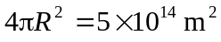, where R is the radius of the earth, about 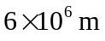, so the surface area of all the oceans is about 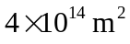. An average depth of about 10 km gives a volume of 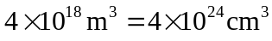. Characterizing the size of a “drop” is a personal matter, but 25 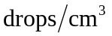 is reasonable, giving a total of 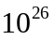 drops of water in the oceans.

